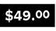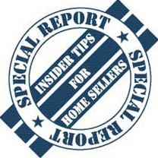

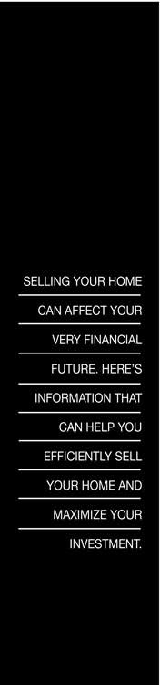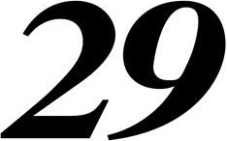Essential Tips That Get Homes Sold Fast (And For Top Dollar)

