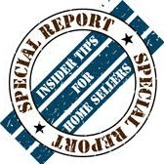Real estate agents tell you advertising is for your benefit. Find out who's really benefiting from their ads and how to select the right real estate
professional for your needs.

The

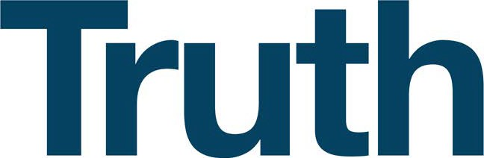
About Real Estate
'-------------' Advertising

