Letter

Mr. & Mrs. Seller
1234 Main Street
Los Angeles, CA 90001

Dear Mr. & Mrs. Seller,

Thank you for giving me the opportunity to present you with my Market Analysis.

For over 14 years, The Real Estate Group has enjoyed a reputation of excellence with competent and ethical performance for my clients. My qualifications include:

Experience Office Support
-Certified Residential Specialist – CRS -Fastest growing in the South Bay
-Licensed Associate for over 10 years -400+ agents to sell your property
-Managing Broker with 35+ years
Low Commissions experience
-Starting at 2%

Satisfaction Guarantee
-Cancel at any time

When you decide to professionally market your property, I stand ready to perform. I am enclosing a couple of my business cards. I hope you will pass them along to any friends or relatives who may want to work with me on estate transaction.

I am looking forward to working with you!

Sincerely,
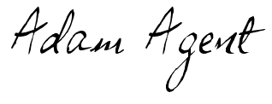
Adam Agent
Licensed Realtor, DRE#000000

